

American International University- Bangladesh

CSC 3222: Web Technologies

CO1.1 and CO2.1 Evaluation

Project Report

Spring 20-21

Project Title: **E-commerce Site Management System**

Section: A

|  |  |
| --- | --- |
| Student Name | Student Id |
| Alam, Md. Iftakhar | 17-35518-3 |
| Bristy, Mushfika Jannat | 17-35530-3 |
| Saha, Amit | 18-36075-1 |
| Chowdhury, Md. Samiul Hauque | 18-36072-1 |

Introduction:

For the last couple of decades, we have seen a massive surge in demand for e-commerce websites & it is only going up during this pandemic (COVID-19). So, we decided to build a website for the users to provide them with a seamless experience.

Background Study

We have researched many websites to get a clear view of the structure of an e-commerce site.

<https://www.amazon.com/>: The world leader in the e-commerce space. We have studied their website to develop a hierarchy model & design.

<https://www.daraz.com.bd/>: A leading e-commerce site in Bangladesh. Navigation style, Menu designs were studied from here.

<https://www.rokomari.com/>: It is one of the most popular sites in Bangladesh. Various information regarding user profile & layouts were researched from this site.

Requirement Analysis:

1. User Category:

There are four types of Users here. They are:

* Admin
* Manager
* Vendor
* Consumer

1. Feature List:

In this project, the “Admin” has the following features:

* Log in / Log out
* Information Update & View Profile (Admin)
* Managers [Add/Remove]
* View Products
* View Vendors List
* Approve Salary (Managers)
* Approve Bonus (Managers)
* View Consumers List
* View Selling History
* Review Complaints Against Managers
* Delete Review of Products
* Approve Membership Purchase (Consumer)
* Send Message (Manager / Vendor/ Consumer)

In this project the “Manager” has the following features:

* Log in / Log out
* Basic Information Update & View profile
* Add/Remove Vendor
* Withdraw Salary
* Review Consumer Complaints
* View Product List
* View Vendor List
* View Vendors Sales History
* Update Vendors Information
* Approve Registration of Vendors
* Request for Bonus (To Admin)
* Send Message (To Admin)

In this project the “Vendor” has the following features:

* Sign Up
* Log in / Log out
* Basic Information Update & View Profile
* Add/Delete Product
* View & Update Product Information
* Approve Preorder
* Withdraw Payment
* View Order List
* Issue Discount
* Complaint Against Manager (To Admin)
* View Selling History
* View Inventory

In this project the “Consumer” has the following features:

* Sign Up
* Log in / Log out
* Basic Information Update & View Profile
* Buy as a Gift
* View Products
* Buy Products
* Return Products
* Preorder Products
* Product Review
* Purchase Membership (Gold, Silver, Bronze)
* Complain Against Vendor (To Manager)
* View Purchase History
* Cancel Order
* Add to Cart

Design:

Draw an entity diagram of your project here.

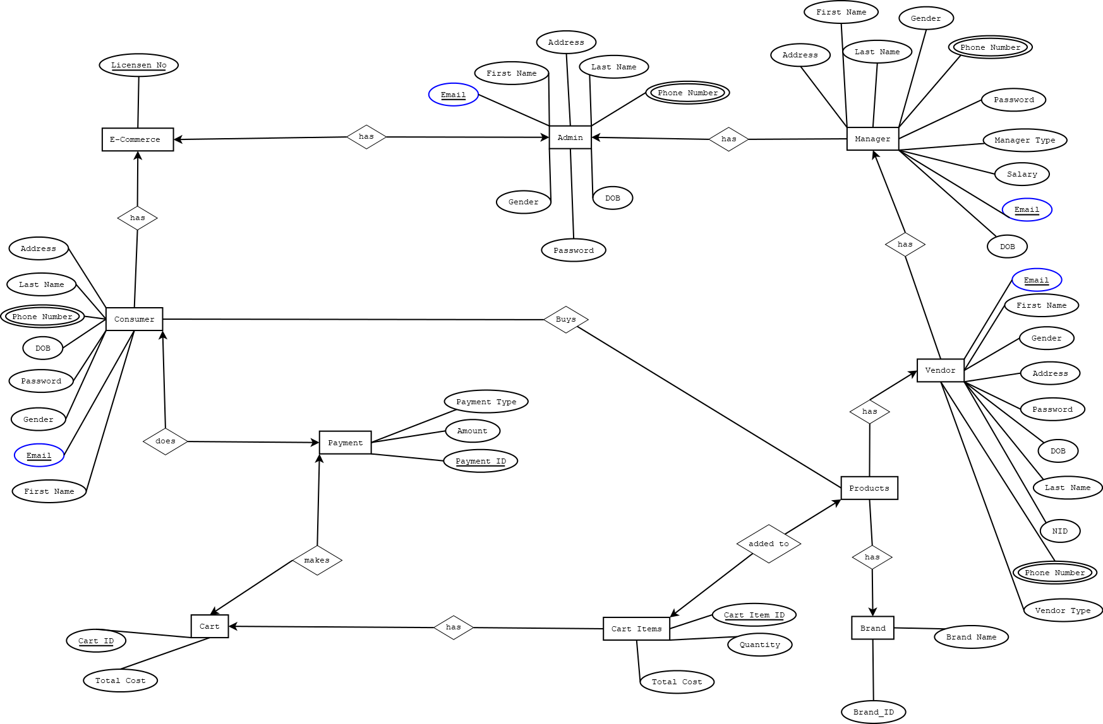

Tools Used:

To develop this project, we have used the following:

• XAMPP

• VS Code

• DIA

• MS Word

• Ziteboard

System Images against the Specification:

Give a screen shot of some GUIs (Midterm project) and write a very small description (Maximum 40 words) for each of the GUIs.

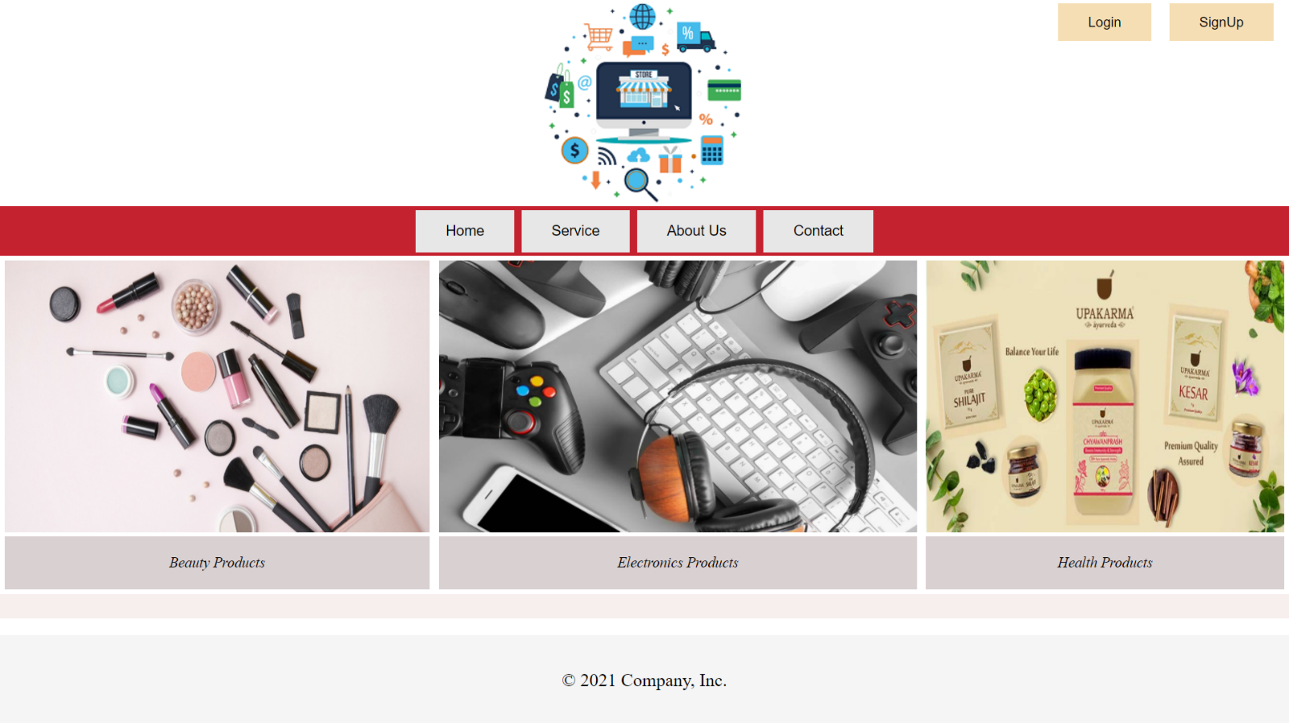

**Home Page:** From home page we can move to login and signup page. It has header, footer and static contents.

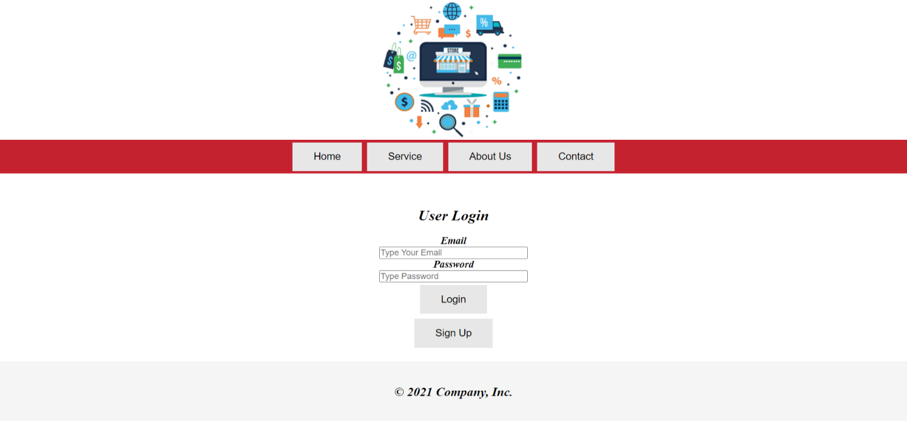

**User-Login Page:** User can login and move to user home page.

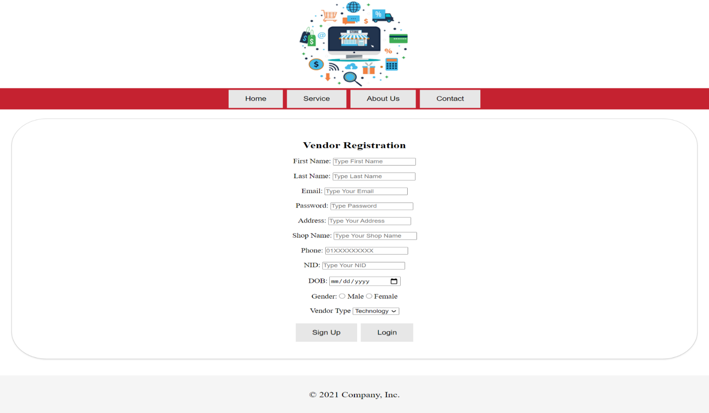

**Vendor Registration:** Vendor can register from this page.

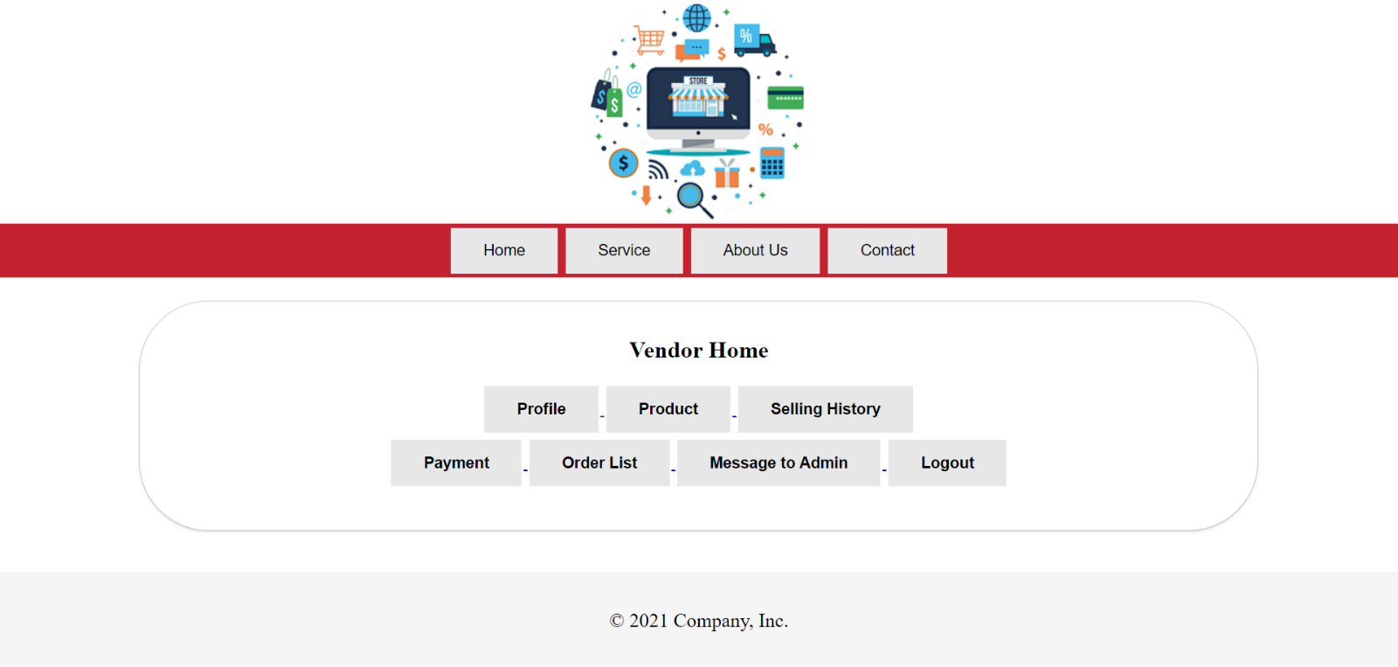**Vendor Home:** Vendor can access all of his features from this page.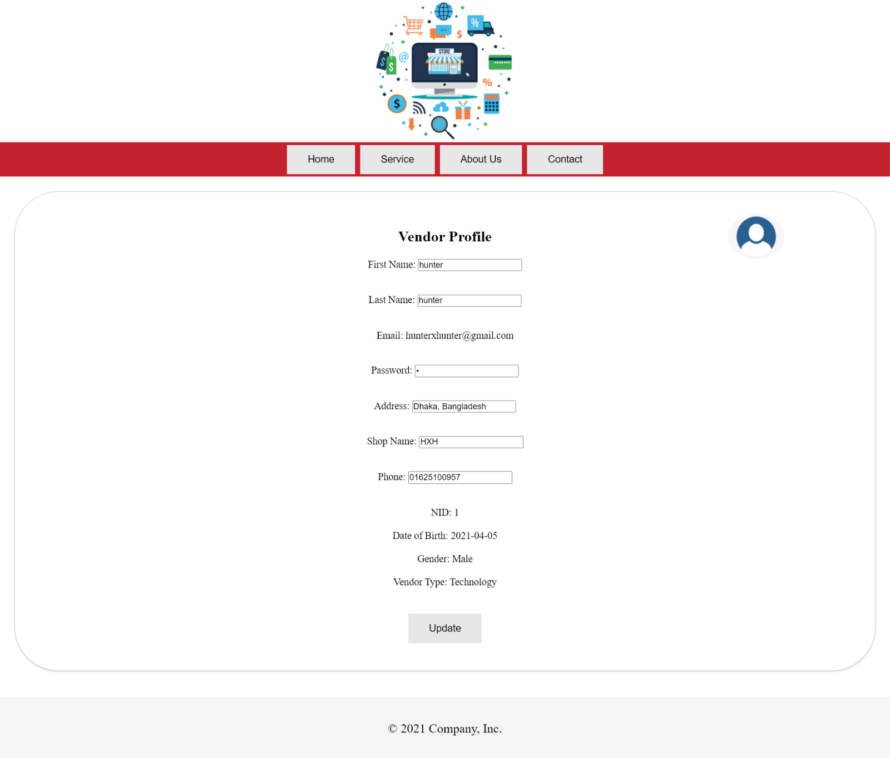

**Vendor Profile**: Vendor can view and update his information from this page.

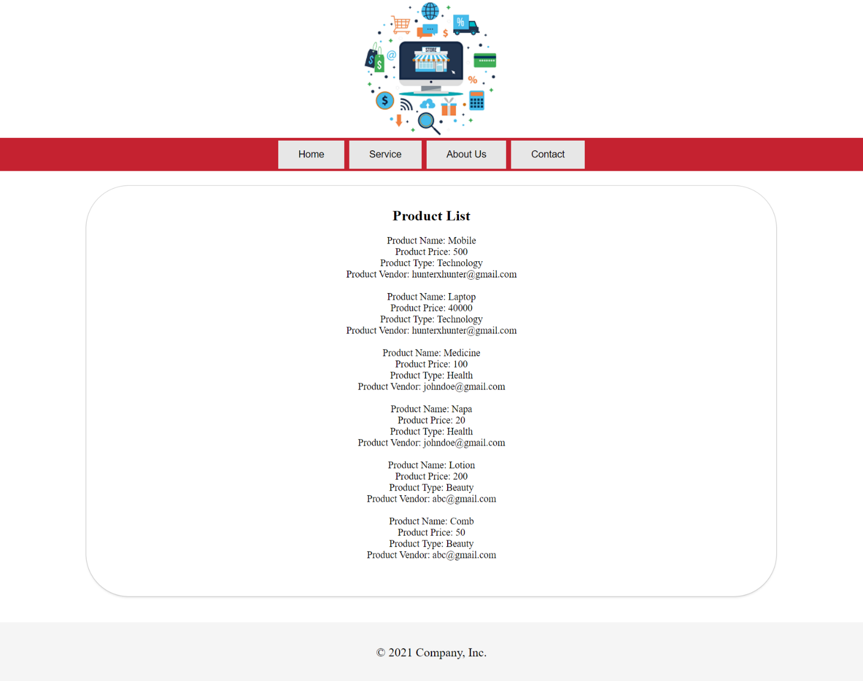

**Product List:** Users can view the products.

Impact of this Project:

Since the 2000, the demand & need for e-commerce websites is increasing at a rapid pace. The convenience provided by an e-commerce site can’t be compared with a traditional store. People can buy products from their home & get it on their doorstep with just a couple of clicks. Especially during this pandemic (COVID-19), we’ve depended heavily on e-commerce sites to minimize the risk. Our project can help out people by providing them with a seamless experience when it comes to online shopping.

Limitations and Possible Future Improvements:

Our project consists of with a very limited amounts of users & products. Right now, we have only used HTML, PHP & a little bit of CSS to design our GUI & to develop our backend logic. The feature list & layout of the pages, design & number of users can be improved in future.

*[Note: Make sure that your report is maximum 10 pages (including cover page). Print (Colored) the report and submit it with spiral bind.]*

|  |  |  |  |  |  |
| --- | --- | --- | --- | --- | --- |
| CO1.1 and CO2.1 Evaluation: Project Report Evaluation | | | | | |
| Project Proposal  (5) | Background  Study  (5) | Requirement Analysis  (5) | Entity  Diagram  (5) | System Images  against the  Specification (5) | Total (25) |
|  |  |  |  |  |  |
|  | | | | | |